

**AMERICAN INTERNATIONAL UNIVERSITY-BANGLADESH (AIUB)**

**Faculty of Science & Technology**

**Department of Computer Science**

**OBJECT ORIENTED PROGRAMMING 2**

**FALL 2023-2024**

**Section: I Group: 03,**

PROJECT REPORT ON

**KHELA GHOR (COLLECTION OF MINI GAMES)**

Supervised By

**TONNY SHEKHA KAR**

**Submitted By:**

|  |  |
| --- | --- |
| **NAME** | **ID** |
| MD. SHOHANUR RAHMAN SHOHAN | 22-46013-1 |
| FARJANA YESMIN OPI | 22-47018-1 |
| MD. ABU TOWSIF | 22-47019-1 |

**Table of Contents**

Topic Page no

1. Introduction ---------------------------------------------------------3

2.User Story ----------------------------------------------------------- 3

3. Features ------------------------------------------------------------- 4

4. ER Diagram --------------------------------------------------------- 5

5. Table Schema of Database ---------------------------------------- 6

6. Implementation Details -------------------------------------------- 6,7

7.Games Overview ----------------------------------------------------7,8,9

8. Conclusion----------------------------------------------------------- 9

9. Future Enhancement------------------------------------------------ 9,10

10. Acknowledgments ------------------------------------------------10

11. Windows Form Images------------------------------------------- 11 - 22

**Introduction:**

Khela Ghor is a Windows application developed in C# using Windows Forms and .NET Framework. It serves as a gaming platform where users can play various small games in offline mode. The application provides features such as user registration, game preview, login/logout functionality, game playing, leaderboard checking, password management, and developer contact.

**User Story:**

Khela Ghor, an exciting Windows application that promises a world of offline gaming adventures. Eager to dive in, users decide to register for an account. The process is a breeze – a quick input of an email, a unique username, and a secure 6-digit password. But here's the cool part: before committing, user can take a sneak peek with the "Preview" feature. It's like getting a glimpse into the gaming wonderland that awaits users.

After signing up, users can log in with their freshly minted credentials. The home screen unfolds with an array of games, each waiting for them to explore. Users can pick a classic game and revel in the convenience of offline play. But it doesn't stop there – they're curious about where they stand among fellow gamers. Enter the scoreboard, their ticket to friendly competition and bragging rights.

Now, being security-conscious, they can decide to change their password. No worries – the settings have got them covered. Just input their old password, set a new one, and confirm it, your account is fortified. And if they ever find themself in a gaming conundrum or just want to shoot a question to the developers, the "Help" section is the go-to source for assistance.

Finally, after a satisfying gaming session, they hit the log-out button. It's right there, waiting for them, ensuring a smooth exit from the Khela Ghor universe. As users can reflect on their experience, they can't help but appreciate the user-friendly interface, diverse games, and thoughtful features that make "Khela Ghor" a promising platform for future gaming escapades. Get ready for a gaming journey like no other!

**Features:**

**User Registration:** Users can register by providing their email, username, and a 6-digit password. This information is securely stored for future logins.

**User Authentication:** Registered users can log in using their username and password. The authentication process ensures the security and privacy of user data.

**Game Preview:** Users can explore the application's offerings by clicking on the "Preview" option before registering or logging in.

**Game Selection:** After logging in, users can access a variety of games from the home screen. The available games include car racing, arcade game, classic snake game, helicopter shooter, and running games.

**Scoreboard:** Users can check their scores and compare them with other players by selecting specific games and viewing the leaderboard.

**Password Management:** Registered users can change their passwords through the settings menu. This process requires entering the previous password and specifying the new one.

**Help and Support:** The application offers a help option where users can contact developers for assistance or provide feedback.

**Logout:** Users can securely log out from the application by clicking on the "Logout" option.

**Entity Relationship Diagram:**

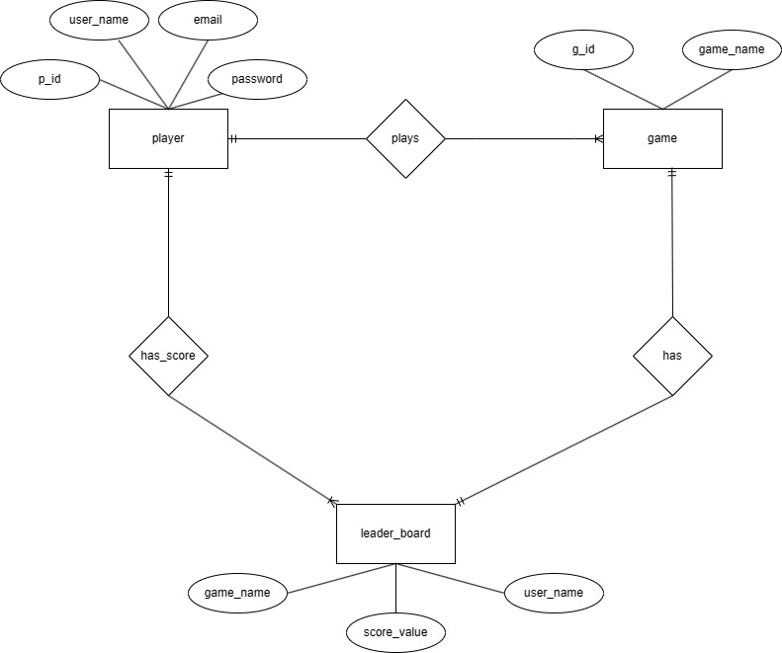

**Table Schema of Database:**

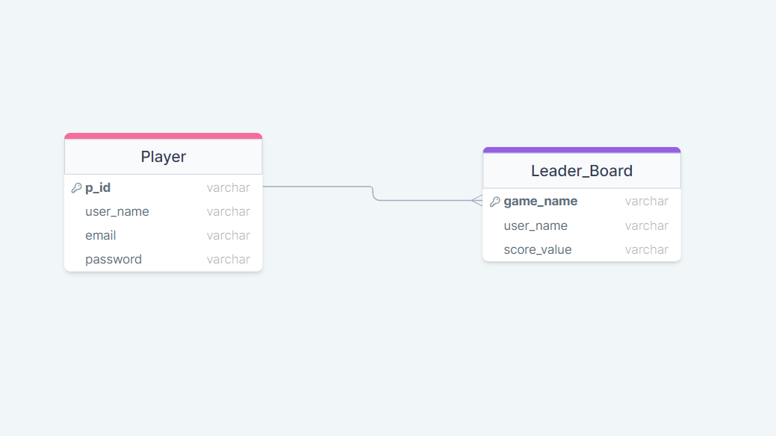

**Implementation Details:**

**Programming Language and Framework:** The application is developed using the C# programming language, taking advantage of the Windows Forms framework within the .NET Framework. This choice allows for the creation of a robust and responsive graphical user interface.

**User Interface Design:** The user interface is designed with a focus on user experience and ease of navigation. Windows Forms provides a range of controls and components that are utilized to create an intuitive layout for interacting with the various features of the application. Consideration is given to the placement of buttons, menus, and game selection options to ensure a seamless and enjoyable user experience.

**Security Measures:** To ensure the security and privacy of user data, industry-standard encryption techniques are implemented during the user registration and authentication processes. Passwords are securely stored using hashing algorithms, and communication with the server, if applicable, is encrypted to protect sensitive information.

**Game Development:** Each game within the application is developed as a separate module, utilizing object-oriented programming principles. This modular approach allows for easy maintenance, updates, and the addition of new games in the future. Game logic, graphics rendering, and user input handling are efficiently implemented to provide a smooth and responsive gaming experience.

**Database Management:** User data, including registration information and game scores, is managed using a database system. This ensures persistent storage of user-related information and facilitates features such as leaderboards. SQL database management system is employed for efficient data retrieval and storage.

**Error Handling and Logging:** The application includes robust error handling mechanisms to catch and handle unexpected scenarios gracefully. Additionally, logging functionality is implemented to record important events and errors, aiding in debugging, and improving future versions of the application.

**Testing:** The application undergoes thorough testing, including unit testing for individual components and integration testing to ensure smooth interaction between different modules. User acceptance testing is also performed to validate that the application meets the specified requirements and provides an enjoyable gaming experience.

**Games Overview:**

**Car Racing:** An exciting racing game where players compete to reach the finish line first, navigating through challenging tracks. The objective is to drive as far as possible without colliding with other cars. Players will be given one car which the player will control through the keyboard. There are cars which will pass through the road randomly. Players will try to move his/her own car without crashing into the other cars. The game will over when the player crashes hit/her own car with the other cars. A restart button allows players to reset the game, providing a convenient way to replay and improve their performance without restarting the entire application. Overall, the game features a dynamic road, player-controlled car, other cars in the road, trophies, and an animated explosion.

**Arcade Game:** The Arcade Game is an engaging ball-bouncing adventure featuring multiple horizontal platforms adorned with floating coins casting dynamic shadows. Players must skillfully navigate the ball across these platforms, collecting all coins in order to successfully reach the exit door to complete the game. A congratulatory popup awaits victorious players, but failure to gather all coins or accidental contact with patrolling enemies on certain platforms will result in a game-over scenario. Players can also check their score and high score in real time. The challenge is heightened by platforms that move both horizontally and vertically, adding an extra layer of complexity to the gameplay. The game's immersive environment, strategic maneuvering, and potential obstacles create a thrilling experience for players seeking to master the art of precision and timing.

**Classic Snake Game:** The Classic Snake Game is a timeless and addictive experience where players initiate the game by clicking the start button, unleashing a snake alongside a delectable piece of food. As the snake consumes the food, it accrues points and extends in length, with the game's speed progressively intensifying every five points achieved. The objective is to navigate the snake across the screen without colliding with its own body; any such collision prompts a game-over scenario, accompanied by a pop-up notification. Players can track their current score and witness the real-time evolution of their high score, creating a competitive and engaging challenge as they strive to master the game and achieve the highest possible score.

**Helicopter Shooter:** The Helicopter Shooter game is an exhilarating C# Windows Form application that provides players with an immersive and action-packed gaming experience. In this dynamic game, players take control of a powerful helicopter tasked with defending against a barrage of objects descending from right to left. The player's objective is to skillfully navigate the helicopter using the arrow keys while strategically firing projectiles with the space bar to destroy incoming bombs. The game's intuitive controls and challenging gameplay create an engaging environment, testing the player's reflexes and precision. With its captivating graphics, responsive controls, and thrilling gameplay, the Helicopter Shooter game offers an enjoyable and entertaining experience for users seeking an adrenaline-pumping challenge.

**Running Games:** This is basically a running game avoiding obstacles developed using C# windows forms (.Net frameworks). In this game, Players will be given a character to jump over the obstacles coming in front of them. There will be obstacles to stop players. Players must jump over the obstacle to gain more points. The game will be over as soon as the player crashes with the wooden obstacles. The game is connected to database, so the overall highest score and the players individual highest score can be saved and viewed in the game.

**Conclusion:**

In conclusion, the development and implementation of Khela Ghor represents a significant achievement in the realm of offline gaming applications. The project successfully merges the principles of object-oriented programming with a user-centric design, providing an engaging and intuitive platform for gaming enthusiasts. The seamless user registration process, diverse game offerings, and robust security measures contribute to the application's overall appeal.

Khela Ghor is not just a collection of mini games; it's an immersive gaming universe where users can register, play, compete, and connect. The user-friendly interface, coupled with the variety of games and thoughtful features, ensures a memorable gaming experience for all users. The project's success is not only measured by the code's functionality but by the enjoyment and satisfaction it brings to the gaming community.

**Future Enhancements:**

While Khela Ghor stands as a robust gaming platform, there are several avenues for future enhancements and expansions:

**Additional Games:** Integrate new and diverse games to continually captivate the user base and offer a broader range of gaming experiences.

**Advanced Leaderboards:** Enhance the leaderboard system with more features, such as filtering options, regional rankings, and real-time updates to foster healthy competition among users.

**User Customization:** Implement features that allow users to customize their gaming experience, such as choosing avatars, themes, or personalized game settings.

**Multiplayer Functionality:** Explore the incorporation of multiplayer functionality to enable users to compete or collaborate with friends in real-time.

**In-App Purchases:** Introduce in-app purchase options for users to enhance their gaming experience, such as unlocking new levels, characters, or power-ups.

**Cross-Platform Compatibility:** Extend the application's reach by ensuring compatibility with other platforms, such as macOS and Linux, to cater to a broader audience.

**Enhanced Help and Support:** Expand the help and support section to include detailed FAQs, video tutorials, and a community forum for users to exchange tips and experiences.

**Acknowledgments:**

We extend our heartfelt gratitude to our project supervisor, Tonny Shekha Kar ma’am, for providing valuable guidance, support, and constructive feedback throughout the development process. His expertise and mentorship have been instrumental in shaping the success of Khela Ghor.

Special thanks to our team members, Md. Shohanur Rahman Shohan, Farjana Yesmin Opi, and Md. Abu Towsif, for their dedication, collaboration, and collective effort in bringing Khela Ghor to life. Each team member's unique contributions have played a vital role in the project's success.

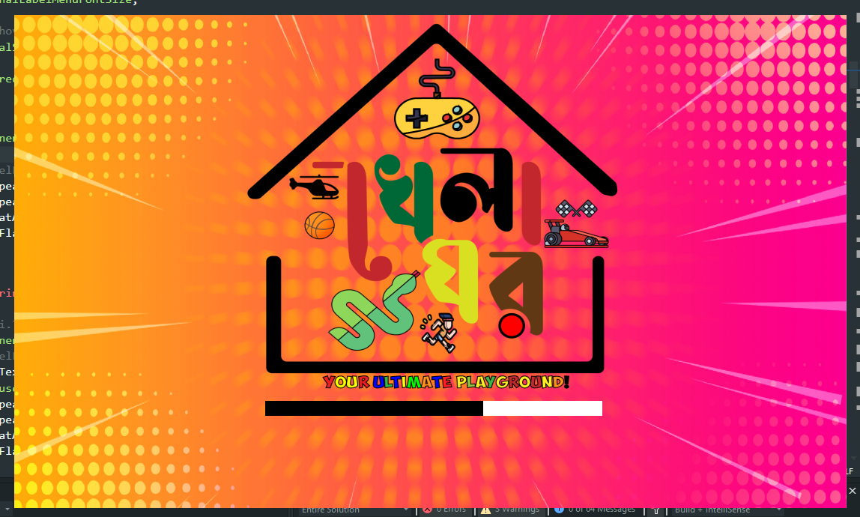**Form Images:**

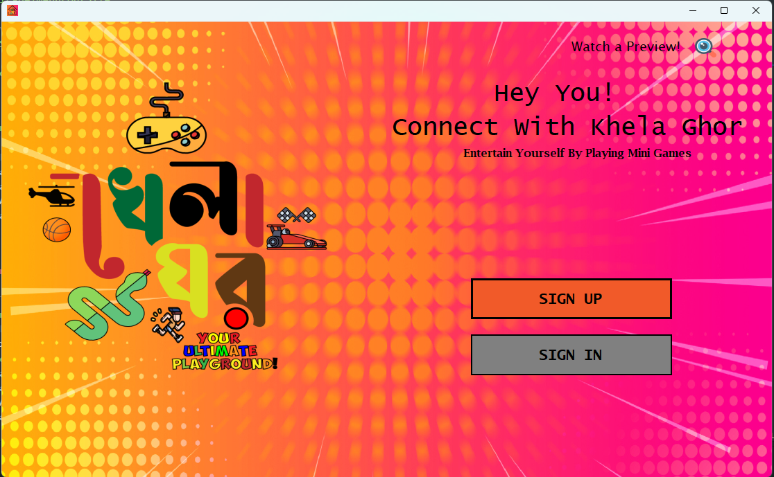Loading Screen

Welcome Page

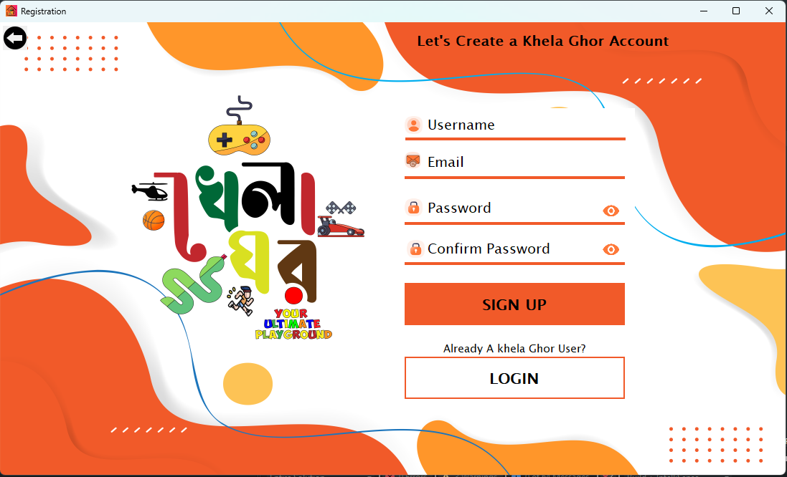Preview button

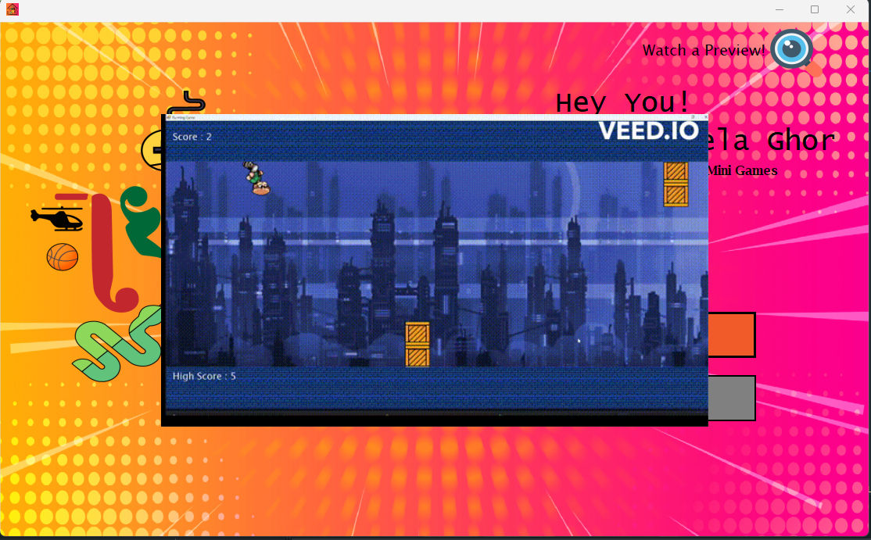Sign up Page

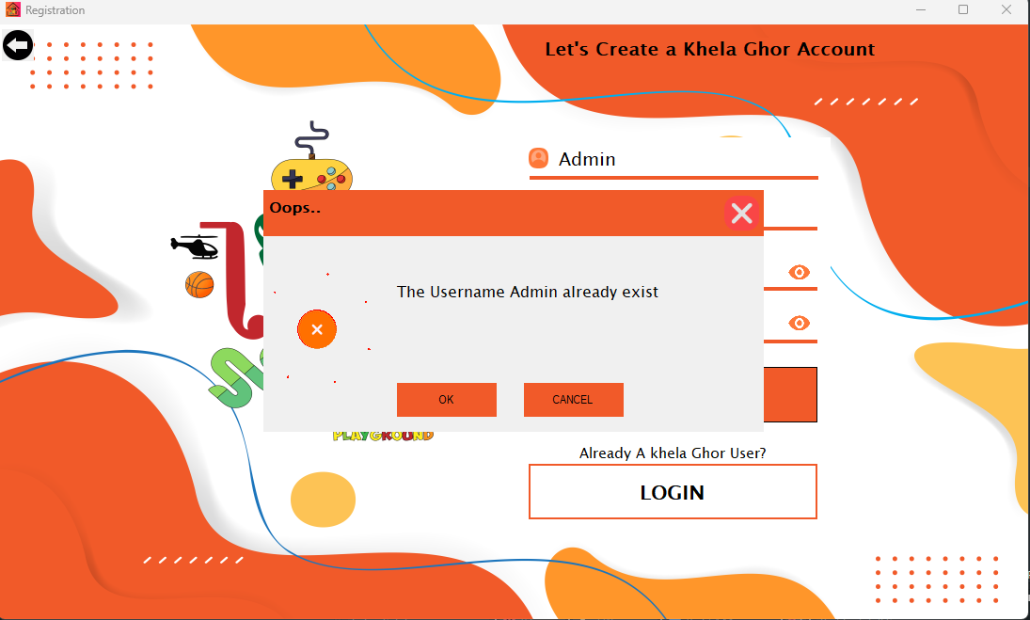Error pop up when invalid details are given



Registration successful pop up with custom animation

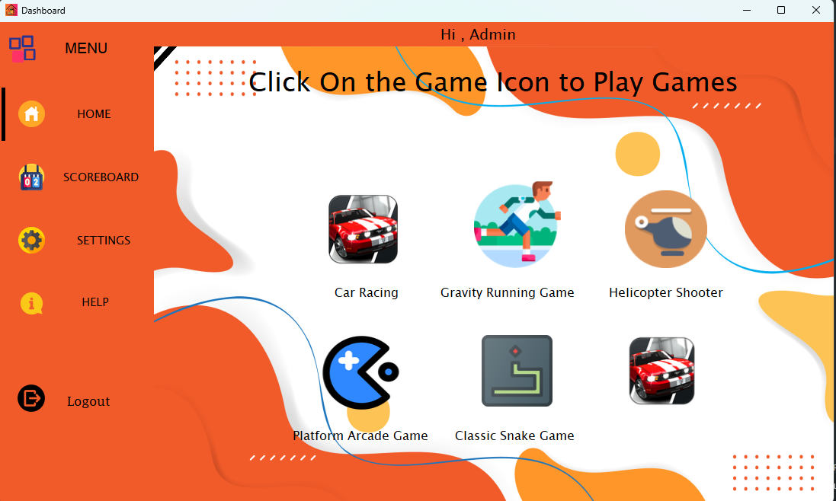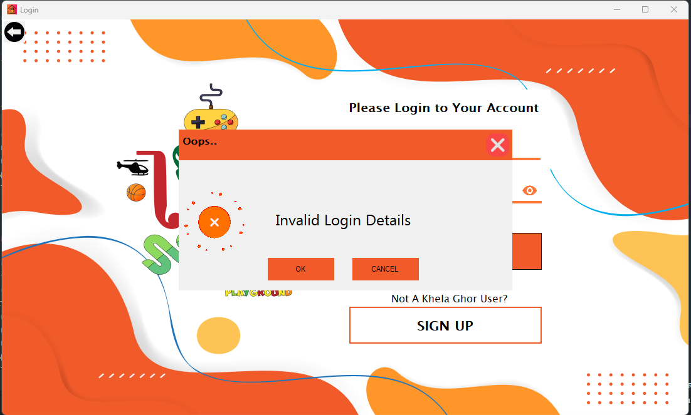Invalid login Details pop up

Dashboard page

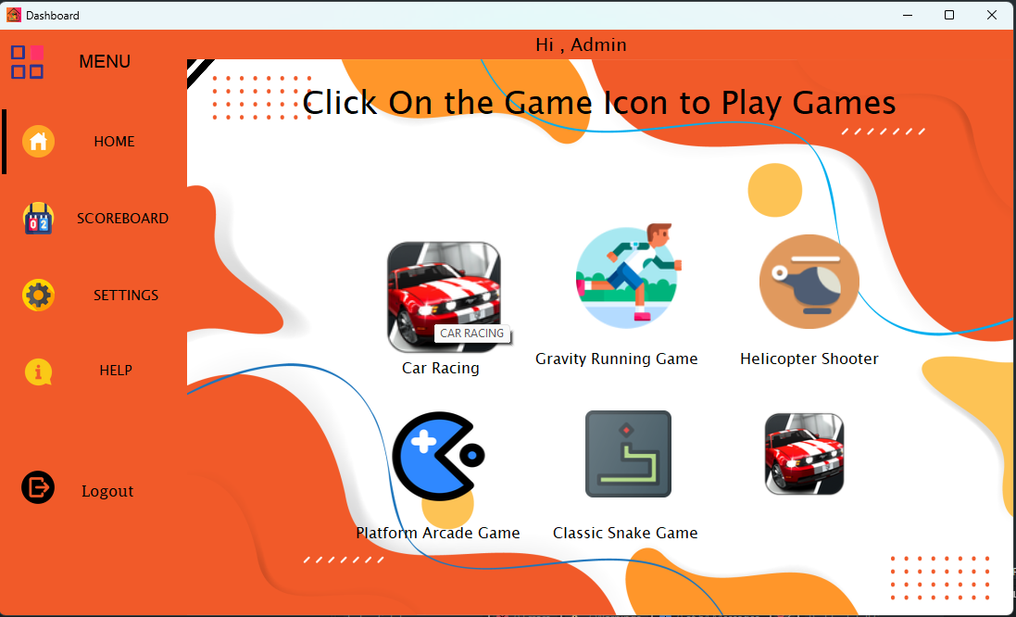Mouse hover icon animation

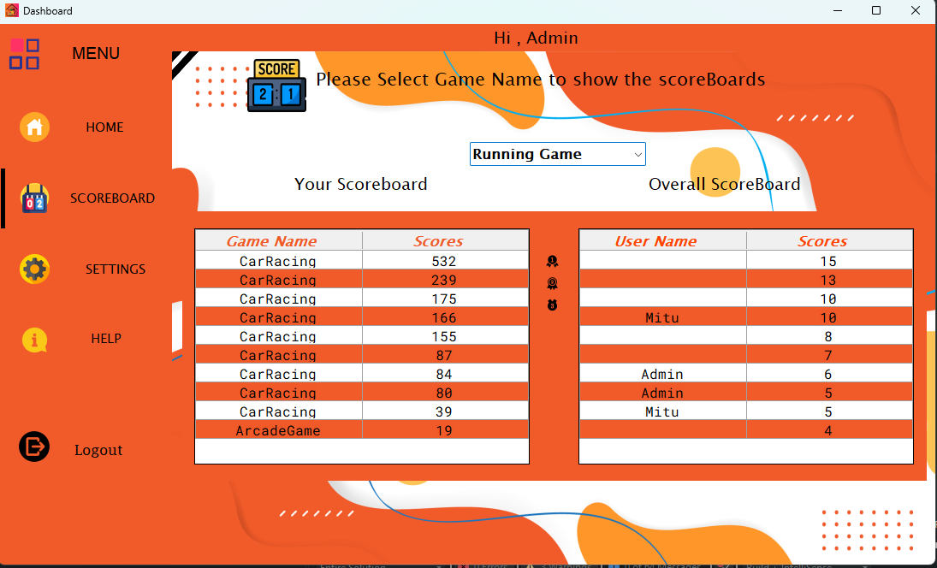

Score Board page

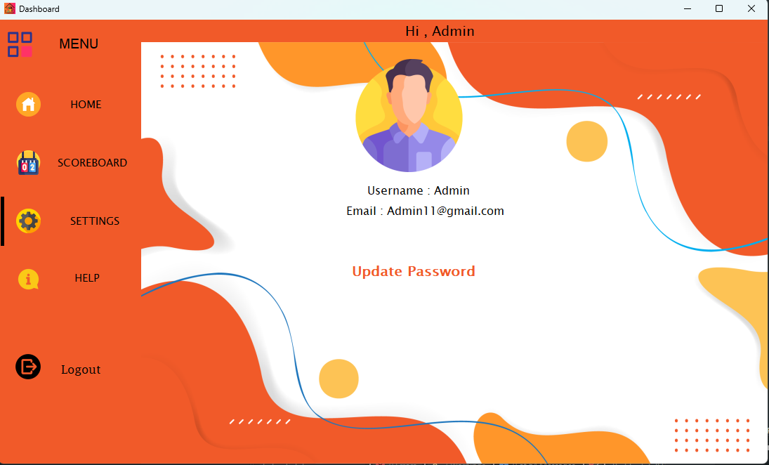Settings Page

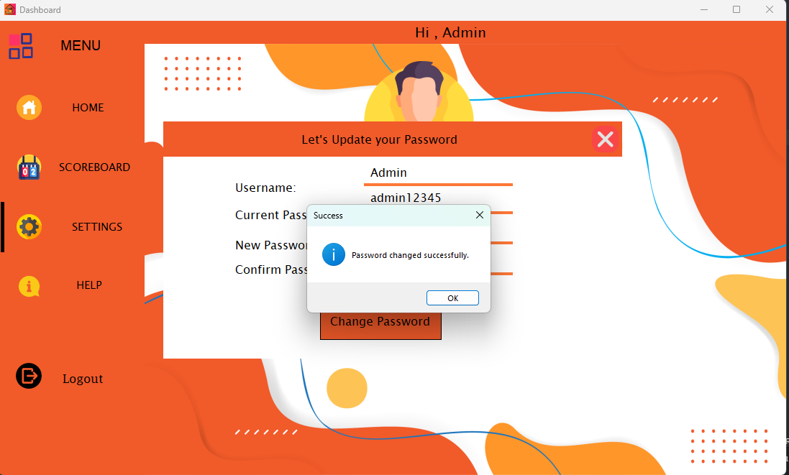

Password changed successfully pop up message

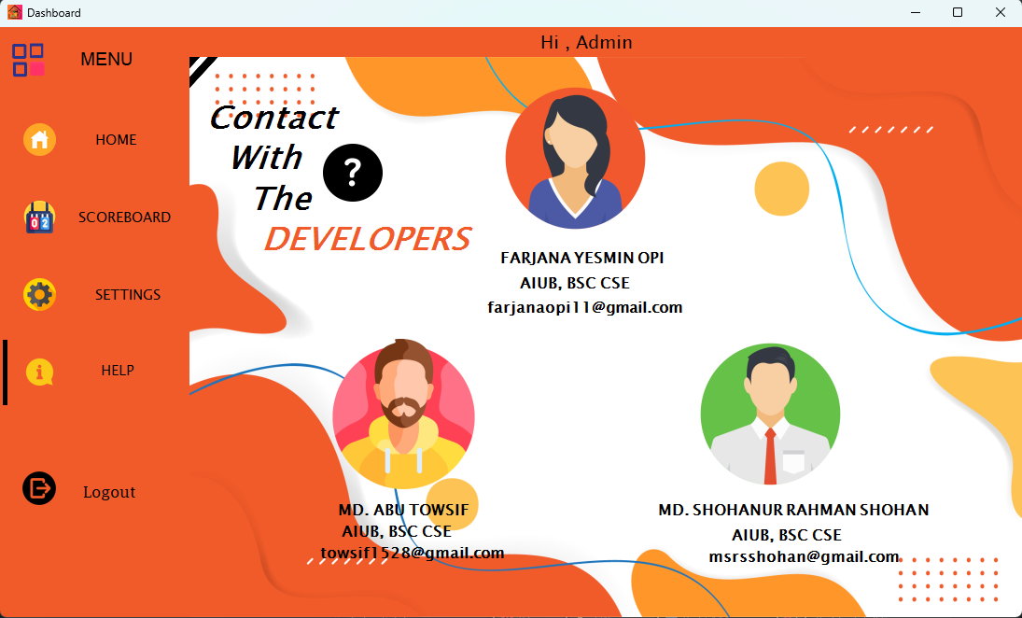

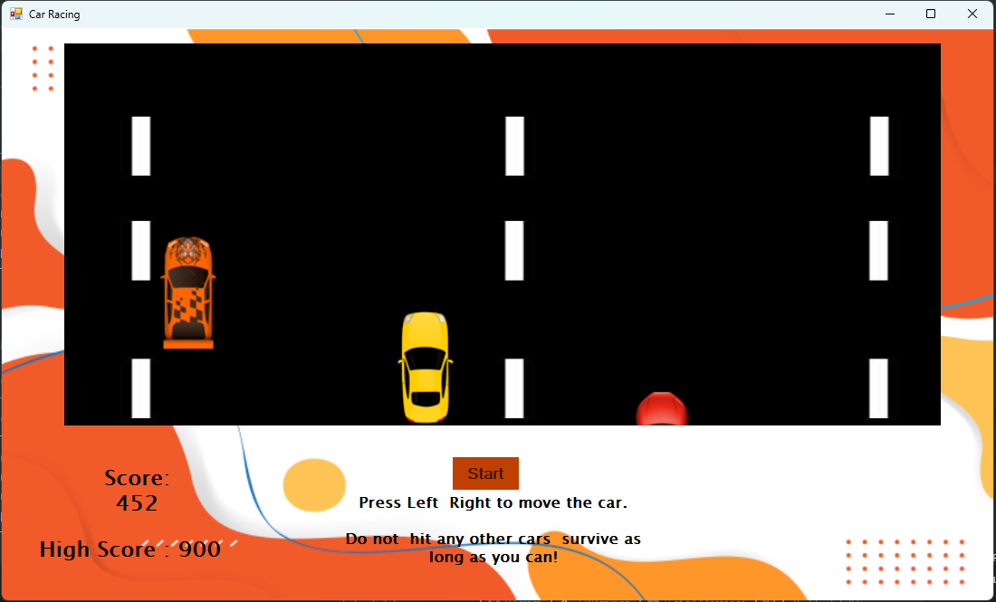Help Page

Car Racing game

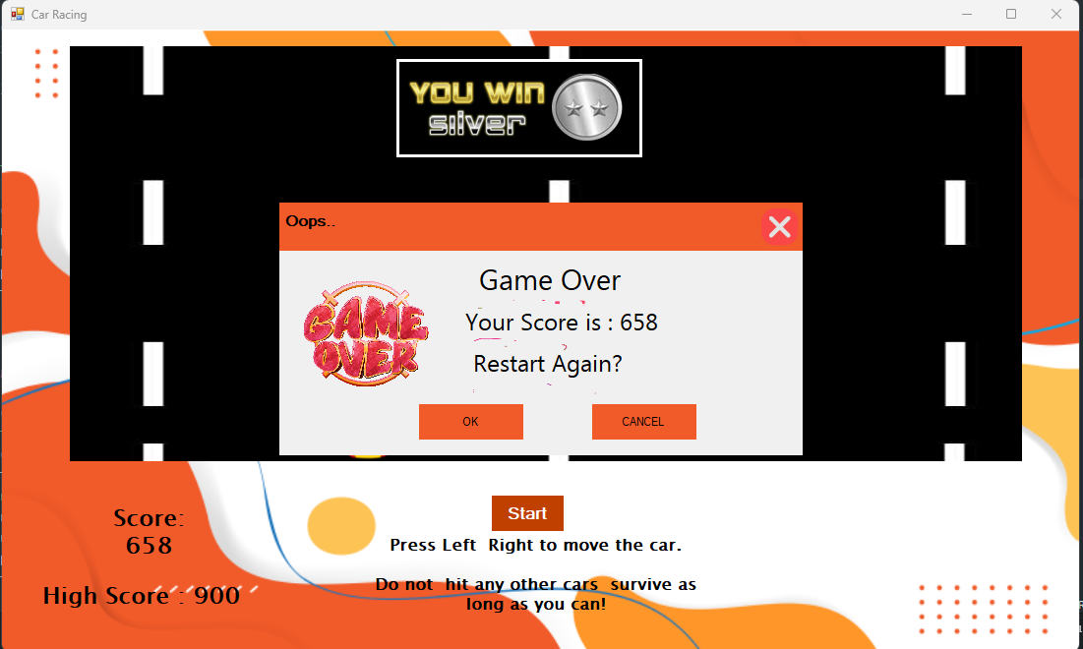Game over popup

Gravity Running Game

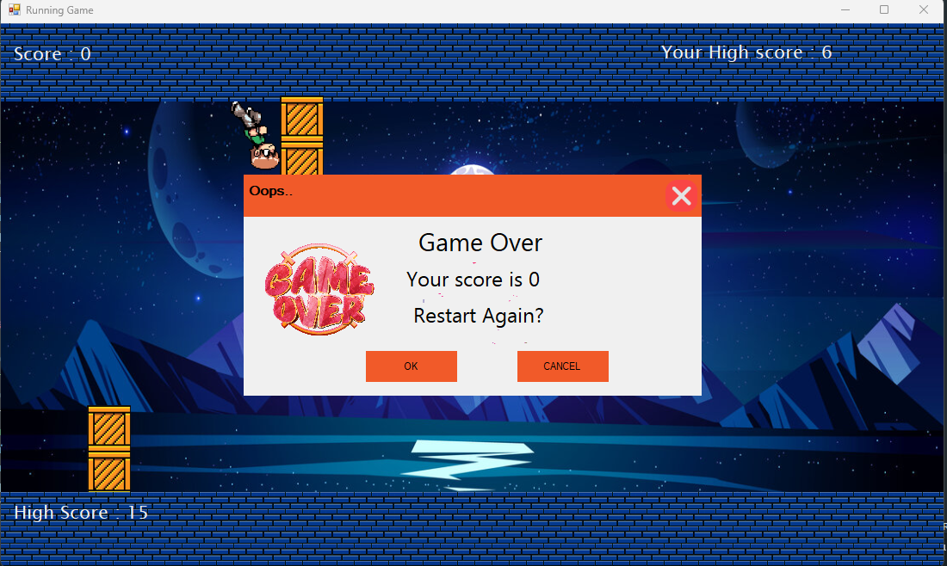Game over Pop up

Helicopter shooter Game

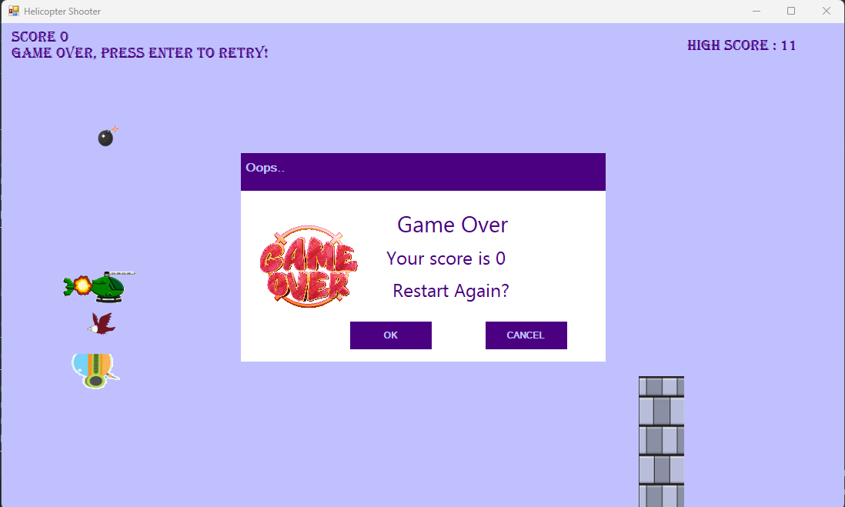Game over pop up message

Platform Arcade game

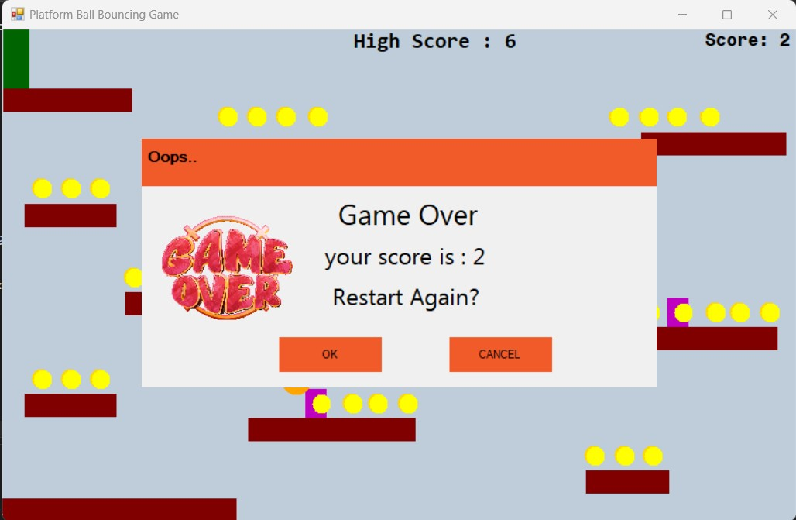Game over Pop up message with score

Classic snake game

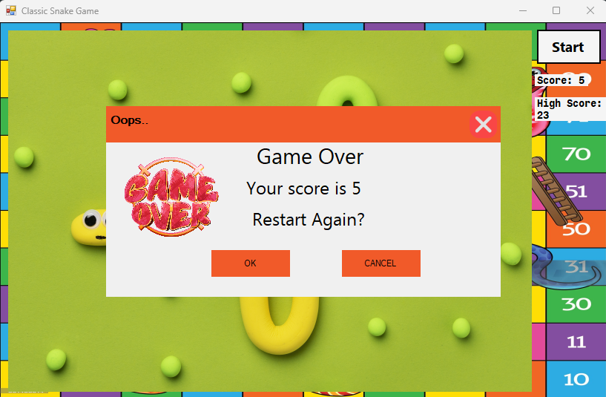Game over pop up message with score